
PEACE ACTION
FORMERLY SANE/FREEZE
1100 Wayne Avenue, Suite 1020
Silver Spring MD 20910
PH 301.565.4050 FAX 301.565.0850
www.PEACE-ACTION.org

U.S. Preparing for a New Generation of Nuclear Weapons?

U.S. Nuclear Weapons Complex

The United States currently has approximately 9,400 nuclear weapons. In 2008 alone the US spent at least $52.4 billion on nuclear weapons and weapons related programs. The United States Department of Energy (DOE) and Department of Defense (DOD) jointly oversee all of the country’s nuclear weapons activities. The National Nuclear Security Administration (NNSA), a branch of the DOD, is responsible for management and security of the nation’s nuclear weapons complex. The U.S. nuclear weapons complex is made up of eight main nuclear weapons laboratories, plants, and facilities across the country where the research, production, maintenance, and dismantlement of nuclear weapons take place.

NNSA Pushes for Increased Capacity to Make New Nuclear Weapons

The NNSA is charged with the maintenance and reliability of the nuclear weapons stockpile, including the ability to design and produce new nuclear warheads. NNSA has been pushing hard for increased resources to the nuclear weapons complex for “modernization,” which would enhance nuclear warhead production capabilities. The Government Accountability Office has estimated that the costs for “modernizing” the complex would cost more than $150 billion.

In particular NNSA has proposed the multi billion dollar construction of three new facilities, respectively in Los Alamos, New Mexico, Oak Ridge, Tennessee, and Kansas City Missouri, that will quadruple our production capabilities from a capacity of building 20 new nuclear warheads each year to a capacity for 80 new nuclear warheads.

Proposed Facilities for Increased Nuclear Weapon Production Capabilities

Site | Location | Function | New Facility Proposed | Estimated Cost of Construction | New Facility Function
Los Alamos National Laboratory (LANL) | Los Alamos,  New Mexico | Nuclear Warhead Research and Design; Plutonium Pit Production | Chemistry & Metallurgy Research Replacement-Nuclear Facility (CMRR) | $2.7 billion | ↑ production capacity from 20 plutonium pits per year to 80, w/ surge capacity of 125 pits
Y-12 National Security Complex | Oak Ridge, Tennessee | Component fabrication, stockpile stewardship, uranium storage | Uranium Processing Facility (UPF) | $3.5 billion | ↑ production capacity from 20 uranium secondaries per year to 80
Kansas City Plant | Kansas City, Missouri | production of non-nuclear components for nuclear weapons | non-nuclear weapons component facility within Kansas City limits | $673 million | Production of non-nuclear components of nuclear weapons
Source: Modern Mission Needed to Determine Modernization Costs. Alliance for Nuclear Accountability. 2010

Congress Pushes for “Modernization” of Nuclear Weapons Complex

In response to Obama’s agenda for a nuclear free world many in congress are seeking to condition further reductions in the U.S. nuclear arsenal with funding for new nuclear warhead production. On December 15, 2009, 40 Republican Senators and one Independent sent a letter to President Obama stating: "we don't believe further reductions [in our nuclear arsenal] can be in the national security interest of the U.S. in the absence of a significant program to modernize our nuclear deterrent." Even democratic senators like Kerry and Levin are on board with modernization of the nuclear weapons in exchange for the passage of treaties like the Comprehensive Test Ban Treaty (CTBT), a nuclear non-proliferation measure banning all nuclear testing.

Unworthy Compromise: Nuclear Weapons Forever!

The nuclear weapons laboratories, contractors and the nuclear bureaucracies in the Pentagon and Energy Department – where the $60 billion in funding for nuclear weapons resides – all have a vested interest in keeping the nuclear weapons policy status-quo. This nuclear priesthood is using ratification of the Comprehensive Test Ban Treaty as leverage for new or modified warhead design and production facilities.

The NNSA and members of congress have proposed the construction of these new facilities to improve the “safety and reliability” of our current arsenal without full scale testing. This argument of necessity has been discredited by the most recent JASON Report, an independent scientific study commissioned by congress and release November 2009. The study finds no evidence for doubting our existing Life Extension Program’s ability to ensure the safely and reliability of our nuclear arsenal for decades to come. This so-called “modernization” of the nuclear weapons complex will only ensuring the reliability of nuclear weapons production, when what we really need is dismantlement.

The Obama administration has stated its commitment to a nuclear-free future, yet with the construction of these new facilities, future presidential administrations could easily resume nuclear weapons production at full speed. Thus investment in new production facilities only further entrenches the primacy of nuclear weapons in U.S. foreign policy.

International Credibility

2010 is widely perceived as a make or break it year for nuclear disarmament. The global nonproliferation regime is on the brink of collapse because of the perception that nuclear weapons states are not disarming as they are required to by Article VI of the Nuclear Non-Proliferation Treaty (NPT). The NPT will be reviewed this May, for the first time post-Bush administration, and after President Obama has received the Nobel Prize for his stated commitment to a nuclear weapons-free world. The U.S. must demonstrate its resolve to the international community by taking concrete actions to permanently dismantle its nuclear arsenal. However, moving forward with plans to expand our warhead production sends a clear signal to the international community that the U.S. is continuing down the Cold War path. The Kansas City Plant is set to break ground (literally) about a month before the NPT; this will be the first new major production plant in the past 20 years!

Environmental and Health Effects

The legacy of the U.S. nuclear weapons complex has been one of environmental injustice. From mining to the dumping of nuclear waste, the nuclear chain has had extreme health and environmental consequences for the communities surrounding the nuclear sites. The toxic burden has been placed disproportionately on indigenous communities targeted for mining, testing, research, and waste storage facilities. U.S. federal law and nuclear policies have been created to allow the nuclear industry to flourish at the expense of the indigenous health, ancestral lands, and ways of life. The over 60 years of nuclear weapons production will cost the United States hundreds of billions of dollars and over five decades of clean-up, and still there will be contamination for hundreds of generations. Increased nuclear warhead production, particularly with uranium and plutonium (the most carcinogenic matter known to exist) facilities will endanger U.S. communities.

What Should be the Role of U.S. Nuclear Complex?

The nuclear weapons complex does have a role in our nuclear age, and that is for nuclear warhead dismantlement, radioactive waste clean-up, and in developing non-proliferation measures such as verification technologies to detect nuclear testing globally and threat reduction measures to reduce and account for loose nuclear materials.

Act Now! Influence the Nuclear Posture Review

The Obama administration planned to submit its Nuclear Posture Review (NPR) to Congress February 1, but has delayed the review’s release until March 1, 2010. The NPR will determine the role and size of the nuclear complex for the next 5-10 years. In a speech to the United Nations General Assembly in September, President Obama stated: “We will complete a Nuclear Posture Review that opens the door to deeper cuts and reduces the role of nuclear weapons.”

The delay in the release of the NPR gives us time to effect the President’s decision. U.S. Senator Russ Feingold (D-WI), U.S. Rep. Edward Markey (D-MA) and U.S. Rep. Pete Stark (D-CA) have written to the president to encourage him to adopt forward-leaning policies in the NPR including taking US nuclear weapons off high-alert status as a safety measure, and adopting a No First Use policy for our nuclear arsenal. So, President Obama is faced with two clear choices. The US will either take a step forward on the difficult path to the abolition of nuclear weapons, or call out to the world its intention to sustain our nuclear weapons arsenal indefinitely.

Contact your Senators and Representatives today and request that they write to the President recommending an NPR that reflects Obama’s vision of a nuclear weapon-free future by taking concrete steps to dismantle our stockpile and reduce the role of nuclear weapons in national and global security policy. Future generations may well look back on these few months as a critical moment when the U. S. committed itself to the bold pledge of its Nobel Laureate President to rid the world of nuclear weapons.

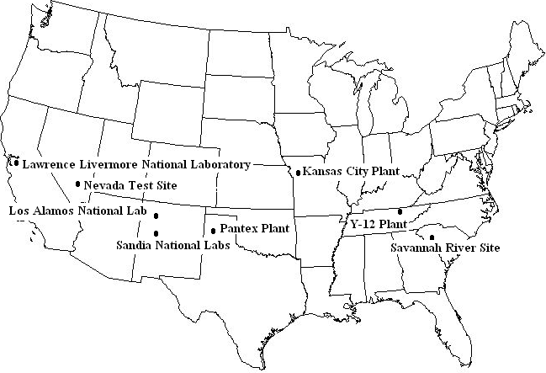
= new facilities underway to increase capacity for new nuclear weapons production

Kristensen, Hans M. Nuclear Notebook. Bulletin of Atomic Scientists. 2009.
Choubey, Deepti. and Stephen I. Schwartz. Nuclear Security Spending: Assessing Costs, Examining Priorities. Carnegie Endowment for International Peace. January 2009.

